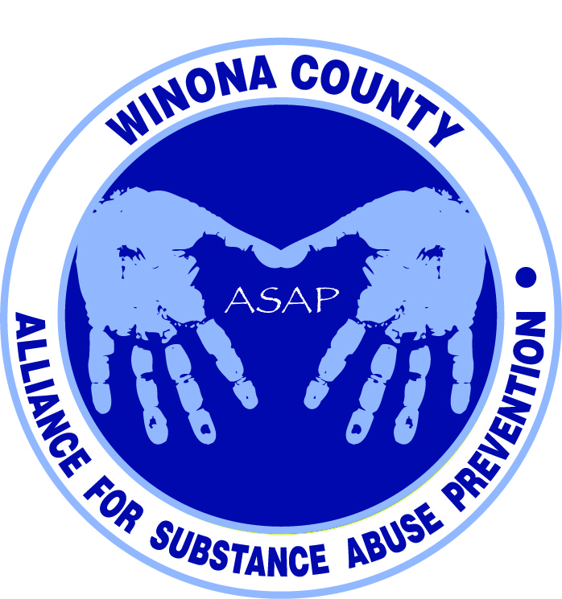

Alliance for Substance Abuse Prevention
Data and Evaluation Committee Meeting
11:30am June 23, 2014

Attendees
Stephanie Nuttall, Peter Sternberg, Mattea Schmitz, Janneke Sobeck, Justin Green, Michelle Rem, Bill Spitzer, Katie Lehmann
Introductions
Mattea Schmitz: Director of Operations for Common Ground, a new outpatient treatment facility. Offers different programs based on level of care. Short term and long term interventions available. Based on their research, they decided to branch out from Rochester into Winona because they felt there were service gaps in Winona. They use a database to view clients served by treatment facilities. Currently assisting adults and will revisit in 6-12 months to consider working with youth. Focus is on drugs and alcohol and integrated dual diagnosis treatment (co-occurring with mental illness).
Stephanie Nuttall: Assistant County Attorney and Diversion Coordinator. Pulls data for County Attorney’s office and CJCC, and has access to several databases including the courts and law enforcement. Also working on a capstone project about underage consumption offenses and looking at BAC levels and locations to see if they changed once the state made underage drinking a payable offense in 2009. She is looking at data from 2006-2012 (3 years before and 3 years after). She is hoping that her project and data will support the proposal to remove underage drinking from the payables list. The project is due the middle of August.
Katie Lehmann: Regional ATOD Prevention Coordinator. Works with coalitions on drug prevention (technical resource, provides trainings)
Peter Sternberg: Professor at WSU. Involved in different aspects of research and finding community involvement opportunities for students. Several of his students held focus groups last semester at Cotter and the Middle School.
Justin Green: Wrote Drug Free Communities grant proposal and will continue to assist with the committees as we prepare our revised grant application.
Michelle Rem: Pastor at Central Lutheran Church. Is seeing more and more adults with drug and alcohol issues that are destroying their lives.
Bill Spitzer: Mayor of St Charles and is running for Sheriff. Concerned about our substance use trends. History of drug prevention – was the DARE officer for 15 years. Now DATE is just taught once in 5th grade. Need to get back to a strong level of prevention.
Notes
Our Drug Free Communities (DFC) grant application was reviewed by a DFC peer reviewer and received positive feedback. Our coalition is splitting into two committees - Data and Evaluation, and Programs and Strategies. We are to focus on the problem of substance use, and not just collect data to support the grant proposal. We need to obtain data to measure the problem and also determine how success will be defined. Eventually the 2 committees will connect and work together. Substances that were focused on in the initial application draft included alcohol, synthetics, and prescription drugs. Tobacco and marijuana were briefly touched on.
2 focus groups were conducted recently by WSU students, which showed a real difference between the private and public school. Public school students were very vocal about their awareness of the issues. Cotter students were uncertain who they could trust with substance use concerns. A similar difference was thought to be the case between WSU and SMU. Peter’s students could conduct additional focus groups and start identifying trends. We would like to include Hope Lutheran in the focus groups.
DFC requires a student survey to be done every 2 years during the grant term. Currently the student survey is done every 3 years in the public schools. Whitewater Country Coalition has been doing the survey every 2 years during their grant term. Justin will attend one of the Whitewater meetings soon to continue the conversation about working together. Committee may want to suggest we approach private schools in Winona County to do a similar student survey.

Action Items
- Scan ASAP webpage and review 2013 student school survey findings: http://www.livewellwinona.org/join-the-community/asap/
- Keeping the target audience of youth under age 18, what questions would you like this group to ask? This exercise will help identify what problems our community has and help define the scope.
- Katie will see if she has a link to individual school data.
- Bill will see if he has the ER reports.
- Justin will connect with Winona Health to get additional ER data.

Next Meeting
July 16th 12:30-1:30pm at Live Well Winona (619 Huff Street)

