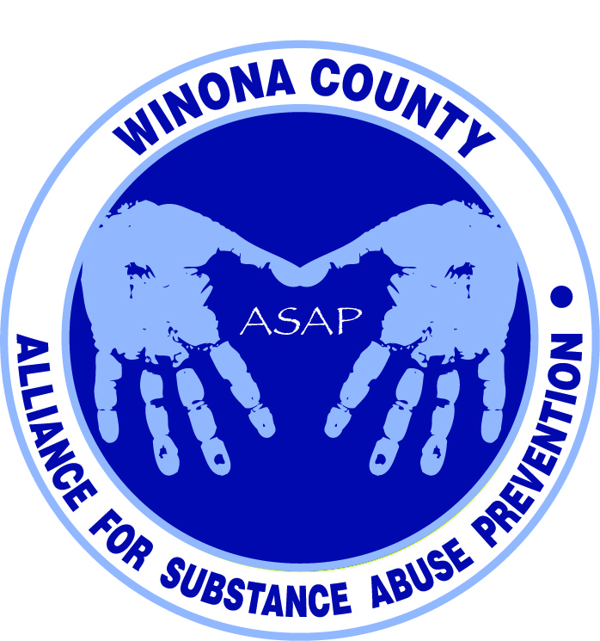

Alliance for Substance Abuse Prevention
Data and Evaluation Committee Meeting
11:00am August 13, 2014

Mission Statement
Bring together organizations and entities in Winona County committed to preventing substance abuse to create a comprehensive program focused initially on residents 18 years of age and younger. By working together, the community will develop effective programs to reach all young residents and encourage them to resist the attraction of substance use.
Attendees
Stephanie Nuttall, Peter Sternberg, Mattea Schmitz, Janneke Sobeck, Justin Green, Bill Spitzer, Deb McClellan
Notes
- Common Ground opened in Winona after identifying a gap through DAANES (Drug and Alcohol Abuse Normative Evaluation System). Anyone can pull data on treatment centers from the state. You can view success rate – transfers, discharges, completions, intakes. Winona wasn’t meeting the clients where they needed to be met.
- Stephanie’s research project looked at 2 years before and 2 years after policy change. The state made underage drinking a payable offense in 2009. She looked at things like the severity of offenses, locations, and recidivism rates. She separated her work into adults and juveniles because of different trends. There was an increase in adult offenses and a decrease in juvenile ones. A concern was that there were 4 cases of first time juvenile offenders that were too drunk to take the BAC test (3 before and 1 after policy change). Number of juvenile offenses dropped from 195 to 144. Severity also decreased. 2 follow up projects she is considering include hospitalization and sentencing (consequences received and what happened next?). Densest part of offenses formed a U shape around Winona State. She wants to review the social host ordinance. The issue might be brought up with the rental association. Looking at time of night would be interesting, especially for law enforcement (focus their efforts better). In St Charles there was a consolidation of offense sites (more juveniles). Big shift – used to see farm parties, but now they are in homes (harder for law enforcement). Suicide hotlines have been taking a lot of calls lately.
- Dialogue around education for parents. There used to be a parent night in St Charles that included a 2 hour class focusing on 5th grade parents, facilitated by the Sheriff’s office. Harmful effects, drug trends, resources. Fairly well attended. Incentivized attendance. Stopped 6 years ago. Need an advocate who can go to the school board meetings. Used to have a comprehensive drug plan for county/city. Had older students speak to middle schoolers. DARE had 4 lesson course for parents but was never implemented. Middle school DARE curriculum is evidence-based. High school curriculum and elementary aren’t. Kate Rusher teaches 5th grade curriculum in Lewiston-Altura district and Dakota.
- Possible area to target parents might be at the mandatory meetings that athletes have. Too late for fall but we might consider getting on agenda for spring if sport seasons are done separately.
- The Alternative Learning Center might be a place to get additional data. Restorative Justice is working with them.
- Peter can assign 3 or 6 students to work on focus groups this semester. Justin can provide context for the students and Peter will provide focus group orientation. Students will create the focus group questions.

Action Items
- Check if DAANES has data on youth (Mattea?)
- Justin will connect with Winona Health to get additional ER data
- Justin will work with the public school to set up a focus group
- Justin will talk to Michelle about Hope Lutheran.
- Janneke will ask Lori Ortega about a focus group at Cotter

Next Meeting
Justin will ask Andrea and Kalene if the whole group (both committees) could meet on September 9th. If we need to reschedule, Tuesdays and Fridays are better for Stephanie – (week of 8th she’ll be in trial). Peter will send his teaching schedule.

