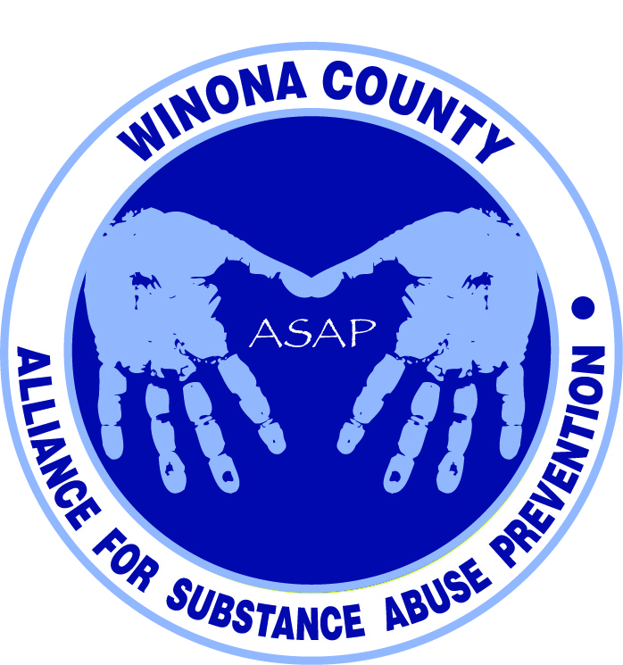

Alliance for Substance Abuse Prevention
Strategies and Programs Committee Meeting
11:30am June 23, 2014

Mission Statement
Bring together organizations and entities in Winona County committed to preventing substance abuse to create a comprehensive program focused initially on residents 18 years of age and younger. By working together, the community will develop effective programs to reach all young residents and encourage them to resist the attraction of substance use.
Attendees
Justin Green, Andrea Gierok, Helen Bagshaw, Phil Huerta, Kristen Lynne, Lori Ortega, Mick Lynch, Marci Hitz, Kalene Engel, Holly Courtenay, Barb Klink, Deb McClellan, Janneke Sobeck, Beth Moe, Ron Ganrude, Lynn Theurer
Notes
Committee to accomplish the following:
- What programs/strategies do we already have. Our target is youth (18 and younger). Includes programs that channel youth into positive alternative activities, or that provide services directly for chemical dependency.
- Collaborate with data committee. Hand over to data committee the information we’ve compiled so they can find data. What programs are being effective? Are they following evidence-based programs?
- Circles back to us to recommend additional strategies to address gaps with evidence-based options. Programs that have proven to be effective.
DFC can’t fund programs. The grant funds a coordinator. For a list of evidence-based programs and practices visit http://www.nrepp.samhsa.gov/
Committee identified what information we want for each program/strategy, including contact information, website, synopsis of program, program goal/mission, and data - what reports are they currently producing, how are they measuring impact? We will begin to compile this list in a Google doc.
The biggest source of data we used for our DFC application was the student school survey. Committee was encouraged to review it on the ASAP webpage.
DFC grant was written but not submitted yet. Application draft is available on the ASAP webpage. Our goal is not to focus on the proposal but on the problem and start doing the work.
Jeremy Hildman from Whitewater Country Coalition likely put together a similar resource directory for their coalition. Justin will be attending one of their upcoming coalition meetings and will get more information.
Suggestion to review http://www.greatrivers211.org/ for programs/services. Looking for the following programs: communication, prevention, intervention, and treatment.
DFC is 18 and younger. Question was posed as to how young we are looking at - is it birth or school age? It was decided to focus on birth and up as we create the database.
Action Items
- Review the committee charge and determine if there are any gaps.
- Scan ASAP webpage and review 2013 student school survey findings: http://www.livewellwinona.org/join-the-community/asap/
- Add your organization to the Google doc if it relates to substance use, along with any other organizations, programs, or services that you are aware of. Leave any fields blank that you are unsure of. Consider the below community map as you brainstorm. The second step will be to complete the data collection/reporting section.
- Justin will invite the Ministerium to add any of their programs or services to the Google doc.
- Janneke will ask Kay Peterson to post this request on the Poverty Roundtable.
- Kristen Lynne will serve as our Lewiston contact and will look into their programming.
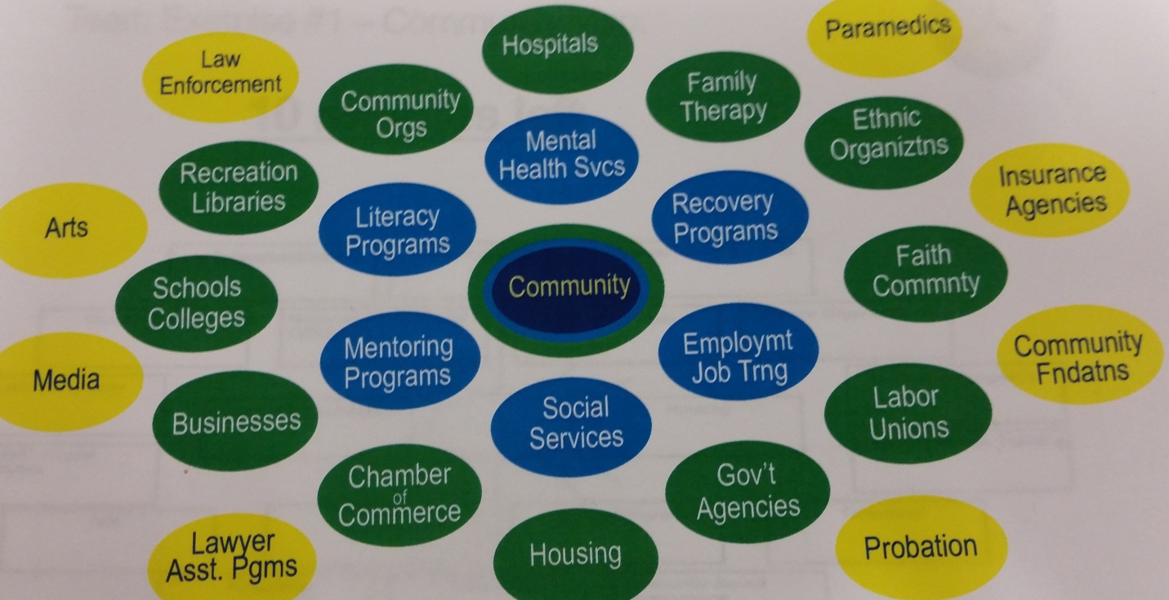
Next Meeting
July 22nd 9-10am at Live Well Winona (619 Huff Street)

