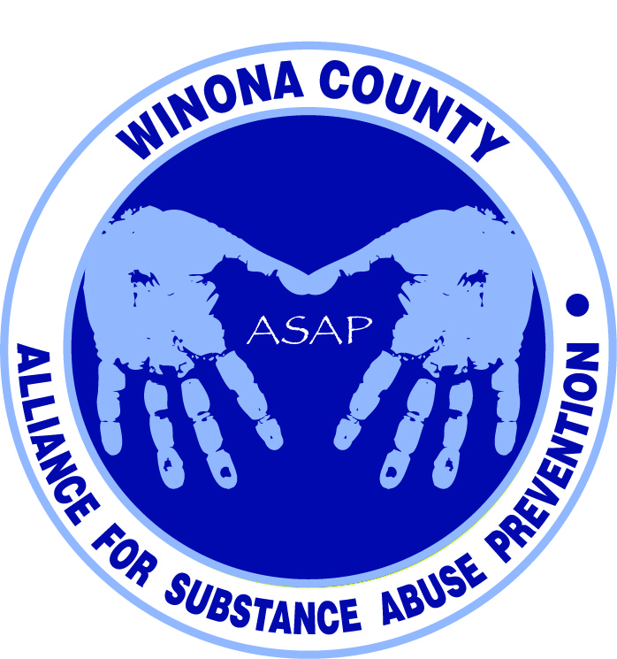

Alliance for Substance Abuse Prevention
Strategies and Programs Committee Meeting
9:00am July 22, 2014

Mission Statement
Bring together organizations and entities in Winona County committed to preventing substance abuse to create a comprehensive program focused initially on residents 18 years of age and younger. By working together, the community will develop effective programs to reach all young residents and encourage them to resist the attraction of substance use.
Attendees
Justin Green, Andrea Gierok, Phil Huerta, Marci Hitz, Kalene Engel, Holly Courtenay, Deb McClellan, Janneke Sobeck, Ron Ganrude, Lynn Theurer
Notes
- Department of Corrections. Diversion program - no juvenile drug court, but other options include corrections officer talk, paying a fine, community service, etc. This keeps it out of the court system. There’s data to show this works. Stephanie determines who is eligible for diversion. Community service people are referred to Restorative Justice.
- Family and Children’s Center. Day program gets referrals from school. Regulate emotions/behaviors. Adolescent programs include educational components about substance use. Don’t have treatment component for substance use. Youth Assertive Community Treatment (ACT) program – 16-21 yrs, dual diagnosis. Licensed Alcohol & Drug Counselor (LADC). Lacking prevention programs. These are interventions (preventing more intensive services).
- Miller Mentoring. At risk youth. Lots of programs/data. How many do they serve and what are the reasons for referrals.
- MN Adult & Teen Challenge. Educational programs for free. CJCC might invite them to speak at Cotter & WSH.
- Pleasant Valley Church. The Landing supports teens. The lessons go hand-in-hand with what parents are going through. Hurts, habits, hang-ups. Issues that are already there, some preventive. 12 step program. Advertise it with DOC.
- Saint Mary’s University. Prevention as soon as they get on campus. Alcohol 101 is educational online with a worksheet. 201 is a group. 301 and drug 101 – individual counseling sessions. Dual diagnosis is addressed – what all is going on.
- Categorize the resources by prevention, education, intervention, treatment.
- Data committee is looking at the student survey data. Peter Sternberg’s class from WSU wants to do more focus groups. Justin will reach out to Cotter and 861 to see about setting them up. Stephanie Nuttall’s master’s project entails plotting underage drinking across Winona.
Action Items
- Identify any other resources/programs that we are missing
- Determine/confirm what youth programs are available and what reports/data they have:
  - Kalene Engel – Work Force Center, Restorative Justice, Gerard Academy, Department of Corrections (program list and what data/reports do they have)
  - Lori Ortega – Winona Senior High, Cotter
  - Andrea Gierok – Winona County Collaborative, Moral Recognition Therapy, Excellent Adventure, Family Based Services through Community Ed.
  - Phil Huerta – Winona Counseling Clinic
  - Lynn Theurer – Rochester Mobile, Pathways, Hiawatha Valley Mental Health Center
  - Kristen Lynne – Big Brothers Big Sisters youth survey
  - Mattea Schmitz – what research/data did you do to identify a need in Winona? Will you target youth in the future? Are you programs based on any specific models?
  - Janneke Sobeck – Miller Mentoring, Winona State University
Next Meeting
2nd week of September. Please complete the Doodle poll to determine meeting day and time. http://doodle.com/k44tmczhm27t2x3u

