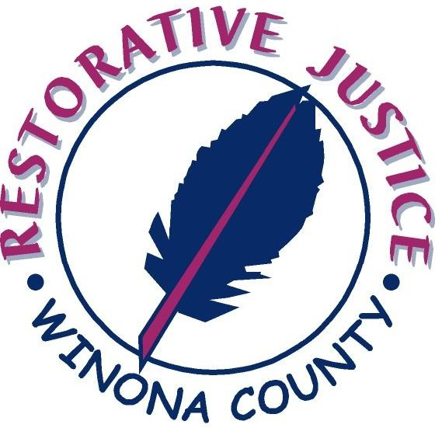

Program Overview
Restorative Justice views crime as a violation of people and of relationships. Those violations create certain obligations, with the central obligation of putting right the wrongs. A Restorative process involves, to the extent possible, all those who have a stake in the specific offense. It empowers victims and communities by giving them a direct voice and it allows offenders to take responsibility for their actions and helps them gain a better understanding of how their actions can affect others.
The Winona County Restorative Justice Program is a community based program that strives to make a difference in the lives of young people. The program is housed with the Department of Corrections and takes a restorative approach to dealing with juveniles. The program’s mission is to “facilitate compassionate responses for crime and wrongdoing that fosters support and healing for the victim; accountability, rehabilitation of the offender; and renewal and safety for the community.”
The following is a list of Programs we offer to Winona County.

- Community Group Conferencing
Community Group Conferencing can be used as an alternative form of conflict resolution or as a diversion from courts. Participation of the victim(s) is voluntary and participation of the offender(s) is based on his or her readiness. The offender(s) must first admit guilt and be willing to participate in the conferencing process. A pre-meeting is scheduled for both the offender(s) and victim(s) to explain the process and to go over what is expected from them. The conference is lead by a trained facilitator, and includes the victims and supporters, offender and their supporters, and community members. Together as a group they discuss and determine the best way to repair the harm caused by the juvenile’s behavior. The process allows both the victim and the community to be directly involved in responding to hurtful behaviors. Community Group Conferencing is available to low level offenders deemed appropriate by the County Attorney’s Office. Conferences are also utilized in the school setting and to address victim/offender incidents ordered through the court on appropriate cases.

- Circles
A Circle is a structured process for organizing effective group communication, relationship building, decision making and conflict resolution. Each Circle is designed to fit the needs of the specific population being addressed. The Circle is run by a “Keeper” who monitors the movement and stimulates reflection of the group through questions or topic suggestions. A talking piece is used as a way of helping all participants communicate respectfully with one another. The talking piece is passed from person to person and the one holding the talking piece has the right to talk while the rest of the circle has the right to listen. This ensures that everyone has the opportunity participate in the circle discussion. The purpose of the Circle is to bring people together as equals to have honest exchanges about sometimes difficult issues in an atmosphere of respect and concern for everyone. Circles are often developed for specific groups of juveniles based on age, gender, interests, or behavior.

  - Boys and Girls Circles
Girls and Boys Circles are offered to ages 10-18. Many of those involved in the mentoring program choose to participate. However, anyone who wants to join the group in circle is welcomed. This program is designed as a way to get more involved and build long lasting relationships with community mentors. The girls and boys circles meet once a month and make time to discuss relationships, compassion, respect, communication, fairness, integrity, honesty, responsibility and many more topics.

  - School Circles
School Circles are offered to all Winona County schools as a prevention and intervention program, designed to explore various topics. The Circles are set up once a week for approximately 30 - 45 minutes to help students develop skills needed to be good listeners and to form healthy, positive relationships within their classroom community. The class will sit in a circle so that everyone can see everyone else be heard. The circle symbolizes the idea of an inclusive classroom community. The discussions focus on building positive character traits, which center on topics such as; kindness, empathy, compassion, respect, fairness, integrity, honesty, responsibility, community, family, peer pressure and others. The goals of the discussions are to create a cooperative learning environment by allowing time for students to get to know one another and to give students the skills they need to solve interpersonal problems and to build positive relationships.

  - Victim Empathy Circle
The Victim Empathy circle is designed as a court-ordered program centered on juvenile offenders being able to empathize with the victims of crimes. By serving offenders who have committed an offense(s) which has a victim(s), the hope is to encourage empathy is young people. This circle is designed as a seven week program, run after school hours. A juvenile offender who has committed an offense(s) where it is possible to identify a person(s) affected (with the exception of domestic violence or sex offending) may be eligible. The program will challenge the young person to face the harm they have caused and consider what they can do to put it right. The Victim Empathy circle will explore principles and values, such as respectful relationships, honesty, openness, taking responsibility, active listening, inclusion and acceptance of diversity, care of ownership, and other important aspects in developing and enhancing empathy.

  - Truancy Circle
Truancy Circles are offered to all Winona County schools. They are a prevention and intervention program designed to improve school attendance, while keeping youths out of the court system. The Truancy Circle is a meeting where parents/guardians, students, school officials, and community members come together with a trained facilitator to talk about the causes of a particular student’s truant behaviors. Everyone has the opportunity to share while participants work toward a fair and attainable solution to the student’s problem with truancy.

  - Chemical Awareness Circle
The Chemical Awareness Circle is a court-ordered program that centers on juvenile offenders being able to understand the consequences of using drugs and alcohol. The CA Circle is held once a month and offenders “graduate” after participating in one session. By serving low-level offenders who have committed drug and/or alcohol offenses, the hope is to better understand the juvenile and better understand the consequences that may result from their decisions. The ultimate goal is to stop substance-abusing behaviors by relating real life events and stories, while promoting positive decision making.

- Mentoring Program
The Mentoring program offers one-on-one mentoring by providing at-risk youth ages 10-18 years with a positive, caring adult mentor. Referrals are made to the program through probation officers, community services, parents/guardians, and schools within Winona County. Mentors are over the age of 18 years, screened, trained, willing and wanting to try new and exciting activities with their mentees. Many of these children are seeking stability in their lives, so a one year commitment of mentors is required.
Matched and unmatched mentors and mentees are highly encouraged to attend the monthly Mentoring Program activities which are supervised by the Restorative Justice Coordinators. The goal of the mentor is to serve as a positive role-model, to demonstrate experiences and choices that they might not otherwise have been exposed to and to provide them with access to people, places and things that are perhaps outside of their normal environment.

- Community Work Service
The Community Work Service Program is designed to provide juveniles with the opportunity to repair the harm they have caused victims and the community. The program also offers juveniles a caring, encouraging atmosphere that includes positive work service tasks that are educational and meaningful. The ultimate goal of the Community Work Service Program is accountability to the community and payment of restitution to the victims. The crew works two Saturdays a month during the school year and once a week in the summer from 8:00 am - 4:30 pm. The crew is supervised by a Restorative Justice Coordinator, site supervisor, and community mentoring volunteers.

