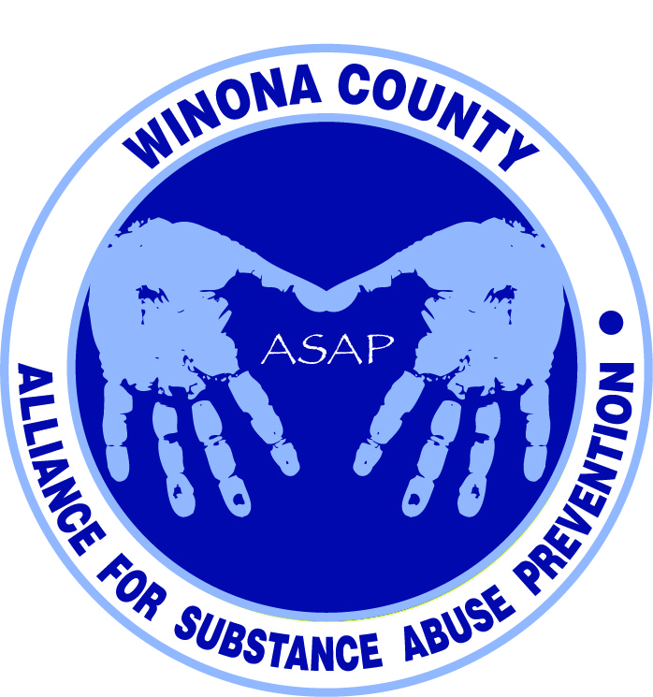

Alliance for Substance Abuse Prevention Meeting
5:30pm February 5, 2014
BA Miller Auditorium, Winona Health

Attendees
Amanda Weifenbach - Parent
Andrea Gierok - Winona County Community Services
Brian Voerding - Winona Daily News
Chris Huston - Gamehaven Boy Scouts
Cindy Amberg - Miller Mentoring
Duane Hebert - Winona County
Helen Bagshaw - Winona Health ICU
Holly Courtenay - Saint Mary’s University
Janneke Sobeck - Live Well Winona
Jeremy Hildman - Whitewater Country Coalition
Justin Green - Volunteer grant writer
Karin Sonneman - Winona County Attorney
Katie Lehmann - Regional ATOD Prevention Coordinator
Lori Ortega - Parent Teacher Association
Lynn Theurer - Community volunteer
Mick Lynch - Winona State University
Morgan Main - Winona State Student
Talon McAdams - Winona State Student
Todd Hoffe - Hiawatha Valley Mental Health Center

Presentation slides are available at http://www.livewellwinona.org/join-the-community/asap/

7th Grade Health Education Class Focus Group Findings
- Alcohol use was perceived as “normal” as all kids had seen it at parties or in their homes
- Kids were concerned about tobacco use at school by the “smoking tree” (lots of head nods of agreement by ASAP meeting attendees)
- Drinking on the bus to and from school was mentioned, and might be a good thing for ASAP to address
- Kids were mostly comfortable talking to their friends, parents, or school counselors about drug and alcohol questions
- Students do not feel that educational materials are current. Videos are not relatable and students aren’t trusting of the content
- Fear of being reported to a superior if kids talked to someone about their questions prevented some students from trusting or confiding in others
- The effects of use and abuse of specific substance are known, but kids want to talk about it. They have questions
- They want to hear real stories from people of a similar age that have been through it
- Kids were very eager to talk to the 2 college students that facilitated the focus group. They trusted them and were eager to ask questions of someone closer in age and in greater proximity to the party scene they associated with college
Grant Application
- Request for Proposals was published the last week of January, with applications due 60 days later
- Grant is looking for the numbers and stories that relate to those numbers
- DFC requires we produce data on 4 substances – tobacco, prescription drugs, marijuana, and alcohol. We know we want to focus on alcohol and prescription drugs, and possibly extend the focus
- Report on Winona County and synthetic drug use recently became available. Recommendations included public education campaign, training for prosecutors, and strengthening laws, to name a few. Legislature is concerned
- Judge Thompson declared at the last Criminal Justice Coordinating Council meeting that public education is needed to help prevent underage drinking

Coalition
- Coalition will not do direct service, but instead serve as a facilitator to connect the community
- We want our efforts to be county wide, so we plan to structure the organization like Goodhue, who is on their second round of DFC funding. The format would consist of a steering coalition (these 12 sector representatives will sign a formal agreement that will be submitted with the grant) and then 3 local committees for St. Charles, Lewiston and Winona
- We have individuals identified and contacted for each of the 12 sectors needed for the DFC grant. More than half have confirmed

