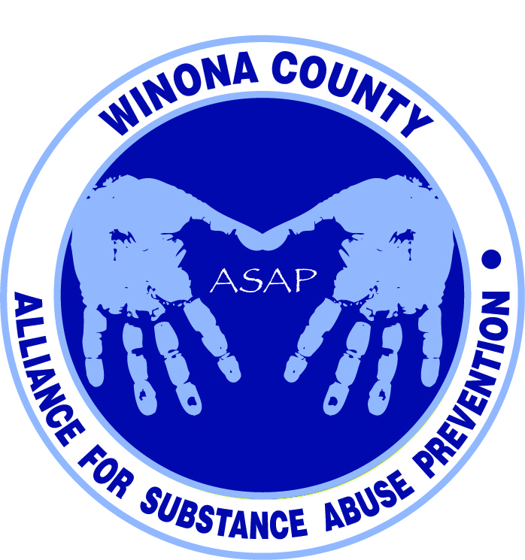
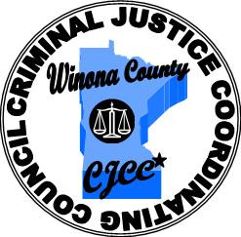

Alliance for Substance Abuse Prevention & Crime Prevention Committee
2:30pm August 17, 2015 - Live Well Winona
Attendees

Chris Huston
Deb McClellan
Holly Courtenay
Janneke Sobeck
Jenna McMillan
Justin Green
Kate Hansen
Katie Lehmann
Kelsey Solum
Ron Ganrude
Travis Volkman
Darci Roesler
Don Cratchy
Amy Carrison

Criminal Justice Coordinating Council
The CJCC is the recognized forum in Winona County for justice system review, analysis, policy development and reform. The Council meets monthly, holds annual strategic planning sessions and accomplishes its work through five standing committees and their associated workgroups. The council consists of many heads of various Winona County departments, and also involves the schools, criminal justice system, and public members. Kalene Engel is the Executive Director.
CJCC sub-committees: Courts, Community Outreach & Diversity, Jail & Jail Alternatives (mental health, diversion programs, what happens when they transition back to community, drug court), Juvenile Justice, and Crime Prevention.
Travis Volkman is the Chair of the Crime Prevention and is now also the Chair of ASAP. The CJCC and ASAP are blending together to enhance the impact of both groups. The common denominators for many crimes are alcohol and drugs.

Alliance for Substance Abuse Prevention & Drug Free Communities Grant
ASAP is a coalition with representation from various sectors of the community, dedicated to the prevention of substance abuse among youth in Winona and Lewiston. The coalition is about building partnerships and collaborations. A DFC grant was submitted in March of this year, with notification of funding expected in August or September. It is a five year grant of up to $125,000 per year with the potential to renew for another five year cycle. It is a competitive and matching grant that does not fund programs. The grant can be spent on staff and operating funds, and relies heavily on volunteers to move toward sustainability. A collaborative structure will need to be established if we get the grant to ensure the same things happen in both Winona and Lewiston.

Action Plan
For the full Action Plan please visit http://www.livewellwinona.org/join-the-community/asap/
The coalition chose to focus on alcohol and prescription drugs for the DFC proposal. Suggestion was made by Kalene Engel prior to this meeting to begin work on the prescription drug disposal and take-back programs while we wait to hear about DFC funding.

DFC Goal One: Increase community collaboration
DFC Goal Two: Reduce substance use among youth.

Reduce illegal access to Rx medications
Create and implement ongoing drug disposal/take-back programs, including on National Prescription Drug Take Back Day
- Determine location of existing drop boxes & need for additional drug disposal drop boxes in the community
- Recruit new locations; Begin a campaign to fund additional drop boxes inc. portable, if needed
- Work with existing drop box locations to coordinate dates and policies for “take-back” days, including from home-bound individuals
- Widely publicize “take-back” days
- Schedule and hold “take back days” to include National Rx Drug Take Back Day

Currently the only known drop box in Winona is at the Law Enforcement Center. Steele County Coalition has recently given out bags to neutralize the chemicals in prescription drugs (available for $3.99 at Walgreens). Discussed the possibility of the public library and Winona Health as potential drop box sites. Winona LEC has taken three loads of drugs for incineration in 3 years. They document the drugs that are collected.

Winona Partners for Prevention of Alcohol & Marijuana Abuse
Winona State University was approached by the state looking for data on student alcohol and marijuana use. Their results qualified them for a state grant from SAMHSA. WSU is part of a seven school cohort. Their coalition will coordinate prevention efforts and leverage resources. They will collaborate with new partners to reduce the prevalence of underage drinking in 18-20 year olds and marijuana use among 18-25 year olds. They will also focus on bridging campus-community partnerships. This grant follows the Strategic Prevention Framework model and involves assessment, capacity, planning, implementation, and evaluation, with sustainability and cultural competence at the center. Our two coalitions will likely experience some overlap, and will stay in close communication to ensure smooth collaboration. WSU will have access to data including date of birth, so ASAP will have access to the 18 and younger population.

Other Updates
Jenna shared some information about a free youth prevention program for schools called Know The Truth. The program travels around the state to P.E. and Health classes. Presenters are young and really connect with the teens.

Katie mentioned that the Planning & Implementation grant RFP will be available at the end of September and due in December. That is a single five year grant focusing on schools to reduce 30 day alcohol use and changing social norms. It sets you up well for a DFC grant. The grant would start July 1st, 2016 and is up to $200k/year. It is a more structured/prescriptive grant than DFC and covers staff and programs.
Next Steps
- Travis - Contact Darren Reed about Steele County Coalition’s efforts with drug neutralizer bags, time spent on disposal of drugs, location of drop boxes, costs, etc.
Cell: (507) 676-0984
Email: safedrugfree@unitedwaysteelecounty.org
- Janneke - Contact Winona Health to see about any past conversations regarding drug drop boxes.
- Coalition - Fill in the coalition gaps. The sector list and who serves each position will be sent out to help generate names to build the local program in Lewiston and Winona.
- Coalition - Read through Action Plan to familiarize ourselves with the proposal.
http://www.livewellwinona.org/join-the-community/asap/

Next Meeting
September 21st at 2:30pm at Live Well Winona. Conversation will focus on the schools and what they are able to do.

