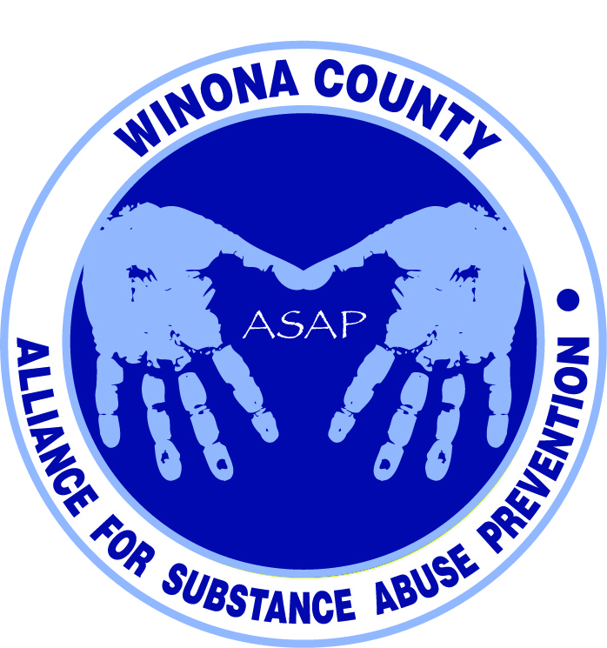

Alliance for Substance Abuse Prevention (ASAP)
11/11/14

Live Well Winona
11am

Attendees
Mattea Schmitz, Janneke Sobeck, Deb McClellan, Peter Sternberg, Lori Ortega, Kristen Lynne, Justin Green, Kalene Engel, Beth Moe, Holly Courtenay, Phil Huerta, Emily Weber, Hannah Lefebvre, Ryan Linskey, Mohamad Farah, Kiersten Kemp, Helen Bagshaw, Lynn Theurer

Notes
WSU Program Planning Class – Needs Assessment Findings
- Hannah Lefebvre, Ryan Linskey, Mohamad Farah, and Kiersten Kemp conducted a needs assessment based on literature review and interviews with Bill Spitzer, Kevin Kearney, and Dr. Brett Whyte.
- Alcohol and prescription drugs were identified as top issues in Winona.
- After researching programs that currently exist in Winona, the below 2 programs were recommended. It was suggested that prior to approaching the Curriculum Director, we ensure our program suggestions meet new standards and would be supported by teachers.
  - Project Alert. Free program that focuses on reducing substance abuse, addressing attitudes, and teaching refusal skills. Two year program that targets 7th and 8th grade. Results show 60% decrease in current marijuana use, 24% decrease in alcohol use, and 40% drop in students already experimenting with tobacco.
  - Life Skills Training. Teaches students personal self-management skills, social skills, informative and resistance skills. Three year program that targets middle school. $175-$275 for curriculum, plus additional resources and workshops. Data was collected 6 years after intervention. Study showed 50% less binge drinkers, and overall lower scores on substance use initiation, less cigarette use initiation, and less marijuana use initiation
- Parent education proposal for spring practicum class to implement included:
  - Awareness campaign
  - Booth at parent teacher conferences
  - Link on school website for parents to become informed
  - Informational newsletter
  - Include valid statistics
  - Town hall during open house (captive audience)
  - Send information through worksite wellness programs
  - Get school administration to talk about it. Currently substance use is addressed in schools in a reactive manner, but it should be proactive
  - Reach non-engaged parents (eg outreach in bars, stickers on bottles of alcohol in liquor stores, parents at sporting events, in media during professional sporting events, at grocery stores)
  - Information packets to partners like Big Brothers Big Sisters, family-based services, scouting agencies, law enforcement, etc.

WSU Program Planning Class – Focus Group Findings
- Focus groups are being conducted at the Middle School, Cotter, and Lewiston. Students will begin doing their analysis this week. 7th grade knowledge of synthetic drugs is scary. Initial report within 2 or 3 weeks. This information will be used to update our DFC grant application.
- Possible additional studies were discussed, including a longitudinal survey with current focus group data as a baseline. Survey could be repeated every 2-3 years once we start the program to determine if what we’re doing is actually changing what’s going on. Another study might be to triangulate what kids are saying vs what parents THINK is going on. Could go back to parents that signed parent consent forms for the focus groups.
Whitewater Country Coalition Update
- Janneke attended the Whitewater Country Coalition meeting last week and proposed that we jointly apply for a DFC grant and imitate the Goodhue coalition model with a health council for each school district and a steering committee over the whole framework. WCC will vote at their next meeting.

Next Steps
- Determine if Winona is eligible for the P&I grant (Planning & Implementation) that WCC is currently funded by, and see if P&I and DFC can overlap.
- Next meeting in December or early January to resolve the possibility of jointly applying for DFC grant with WCC, and learn about the WSU Program Planning class findings from the focus groups.

