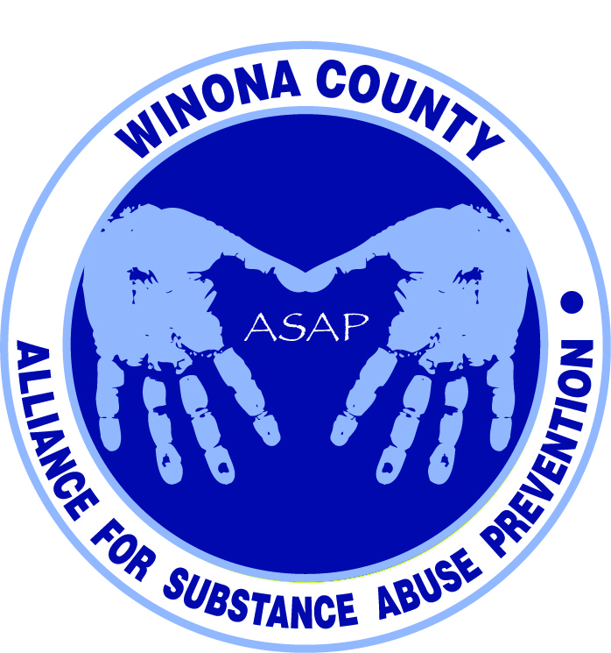

Alliance for Substance Abuse Prevention Meeting
5:30pm December 9, 2013
BA Miller Auditorium, Winona Health

Attendees
Bill Spitzer - City of St Charles
Stacey Sadowski - Live Well Winona
Janneke Sobeck - Live Well Winona
Justin Green - Volunteer grant writer
Kalene Engel - CJCC Coordinator
Katie Lehmann – RPC, DHS
Andrea Gierok - Winona County Community Services
Lori Ortega - Parent Teacher Association
Ron Ganrude - Winona County Sheriff’s Office
Christina Davenport - Winona County Attorney’s Office
Nicole Thompson - DOC, Restorative Justice
Kathryn Jargo - Winona County Community Services
Mick Lynch - Winona State University
Marci Hitz - Family & Children’s Center
Holly Courtenay - Saint Mary’s University
Helen Bagshaw - Winona Health ICU
Suzzanne Plaisance - Winona Health Outpatient Behavioral Health
Lynn Theurer - Community volunteer
Todd Hoffe - Hiawatha Valley Mental Health Center
Brett Whyte - Winona Health Emergency Department

Presentation slides are available at http://www.livewellwinona.org/join-the-community/asap/
Next meeting is February 5, 2014 at 5:30pm in the BA Miller Auditorium, Winona Health

Coalition
- Coordinating body that facilitates and creates more through synergies. Funding cannot be used for direct programming.
- Commitment will be a monthly meeting, and eventually become a quarterly meeting. ~1.5 hours

What are we doing WELL?
- Strong leadership in the community regarding prevention.
- Good at treating extreme cases such as overdoses.
- Restorative Justice is a program for 10-18 year olds that are at-risk or low level offenders. Offers a mentor program, work on communication and social/emotional development, and a variety of ‘circles’ including chemical awareness to focus on the consequences of using.

What are we doing that we can IMPROVE?
- Higher degree of structured programming.
- Advertise that excess prescription drugs can be dropped at the Law Enforcement Center.
- Giving parents in the ER a phone number for their child to follow up with is not sufficient.

What are we NOT doing that we OUGHT to do?
- Mental health and chemical dependency need to be a dual focus. New Winona Health provider Leanne Morey in Psychiatry & Counseling focuses on youth and dual diagnosis.
- No comprehensive list/inventory of resources and programs (moving target).
- Parents/guardians want information but don’t know who to contact.
- Lack of awareness and denial about the issue.
- County just got a grant for crisis intervention to help people get the level of care they need.
- There is a gap for adolescent mental health on the inpatient side.
- Evaluation is missing - assess the need, remove duplication, and track progress of programs.
- Psychiatrists are retiring and recruiting is a challenge. Motivation and momentum are lost if the person has to wait months for an appointment.
- There is no prevention course for the ‘medium’ risk (people who are experimenting).

What are we doing that we should STOP doing?
- Stop programming that is not evidence based. Need supportive data.
- Stop treating chemical dependency and mental health in isolation.

Questions:
- Where do the 10-14 year olds show up in our data? They are not in the judicial system. Whose expertise or experience can be referenced for the grant?
- What 2-3 drugs should our coalition focus on? Alcohol, prescription drugs, and synthetics?

